Coaching Requirements

CRIMINAL RECORD CHECK

All Coaches, Managers, Board Members and staff etc are required to submit a current CRC (they are valid for 3 years). Please review the attached PDF for instructions. Have your BC Identity/BC Driver’s License Card available. If you haven’t already done so, you will be required to download an app to complete the BC Services Mobile Card. It seems we will be using this for many things in our future besides doing Criminal Record checks. You will need to send a photo & video to get verified without talking to Service BC or, place a video call or, verify in person. Get started here. BFC’s Access Code is LZXJDJHMJR

COACHING CERTIFICATION OVERVIEW

BFC will provide support to our grassroots coaches and cover the cost of their certification process. It can be confusing for some to navigate so we are providing some details in this section to help you with this is process. The chart below provides you with a brief outline of the different levels required at the youth level.

Canada Soccer Grassroots Coach Education Program is an introduction to soccer and coaches may register for any of the 4 courses (Active Start, Fundamentals, Learn to Train and Soccer for Life). Each course focusses on a different stage of development regarding children, youth and adult levels of play and coaches are not formally evaluated at these levels. Coaches need to complete the Online Theory and Practical Field Components to receive certification credit. There is no pre-requisite to register for these courses.

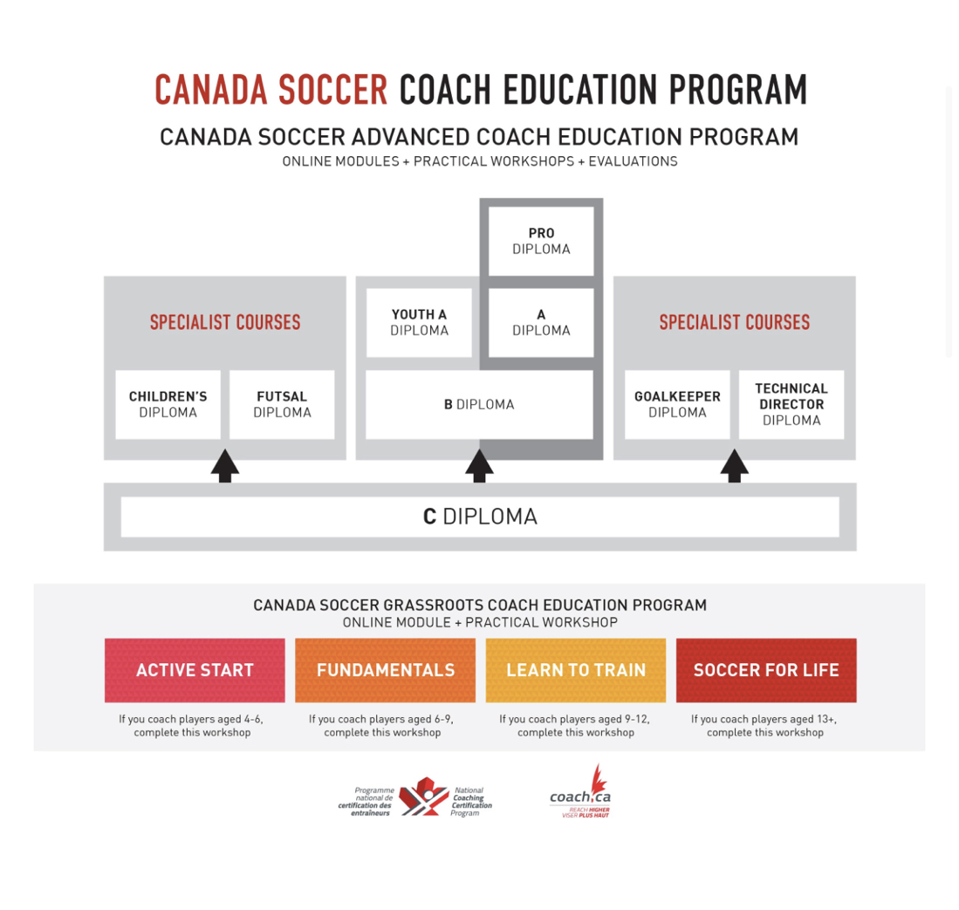

The online theory component (part 1) is for coaches who want to start their certification process and then finish the practical on-field component (part 2) to obtain their full certification. It is made up of various modules to help you become more knowledgeable at the age specific stages of development that you coach.
Work at your own pace to complete these modules which may only take about 60-90 minutes in total to finish the entire course. To receive full certification credit, all coaches are required to successfully complete the online theory component (part 1) as a pre-requisite first before being able to register for the practical on-field component (part 2).

Once both parts have been completed, you will receive certification credit for the respective level. If you are or will be coaching in one or more of the following age groups and previously have not completed this course requirement, then the online theory is your first step. Burnaby Football Club will be offering the on-field certification courses for Active Start, FUNdamentals, Learn to Train and Soccer For Life. You can find the dates here.

COACHING CERTIFICATION COURSES (ONLINE) AND REGISTRATION STEPS

Duration: 1 - 1.5 hours online per course

Cost: BFC will cover the cost of your grassroots certification course and provide you with an access code once you are ready to register.

Timeline: We ask all coaches to have completed their age level online course prior to the start of the program they intend to coach with or within 30 days of signing on as a coach).

Steps:
1) Register for a National Coaching Certification Program number by visiting here.

2) Create an account with BC Soccer certification program (Coach Centre) by visiting coachcentre.ca. When you register for your Coach Centre account make sure you use the same name (exactly) and email that you used to create your NCCP number/account. Enter your locker (NCCP number) with coach centre.

3) Register for certification courses (Active Start for U5 and U6 and FUNdamentals for U7, U8 and U9, Learn to Train for U10 to U12 and Soccer for Life U13+). Once you are ready to do your online course let the Club know (coaching@burnabyfc.com) and we will send you an email with an access key you can then use to do the Canada Soccer online courses.

STEP 1: Request email with access code from coaching@burnabyfc.com.
STEP 2: Click on the link provided in the email or here.
STEP 3: click on Register for an Account.
STEP 4: Enter course key I will send you by email and make sure you use the same name (exactly) and email that you used to create your NCCP number/account. You will be asked to complete the Coaching Soccer in Canada course (short) before then starting Active Start, FUNdamentals or Learn 2 Train.

Once you have completed the online course you will receive credit for the course(s) with coach centre and NCCP.

OTHER REQUIREMENTS (as per Canada Soccer guidelines):

MED: Making Ethical Decisions: click here. You can try to do this evaluation right away (it only takes about 10 minutes) but you only have two cracks at it to pass (75%).

Making Headway: click here

RiS: Respect in Sport: click here. This course is required by both BC Soccer and Canada Soccer and can be done in stages and takes roughly two hours. BFC has purchased access codes so we hope our coaches will complete this requirement.

Program Access Instructions:

- If you have an existing Activity Leader Program certificate, select “Already Certified?” and follow the prompts.
- If you have an existing profile in any other Respect Group program, select “New to this Program?” then “Look-Up”.
- If this is your first time registering for a Respect Group Program, select “New to this Program?” followed by “Register”.
- Complete registration.
- Select “Submit” at the bottom of the page. You will be requested to review and accept the Privacy policy.
- On the payment page, click “Enter Code”.
- Pre-Registration Code: email coaching@burnabyfc.com for code.
- Once successfully logged in, you will default to the Home page. Select “Program Access” to view the modules.
- To re-access the program, return to the same URL indicated and enter the username and password you created during registration.

As a Canada Soccer Youth License Holder we are obligated to meet all coaching certification requirements and we are committed to supporting all our professional and volunteer coaches in meeting these standards.

Thank you once again for all of you support in our community.

